H.T. No: 2303A51656
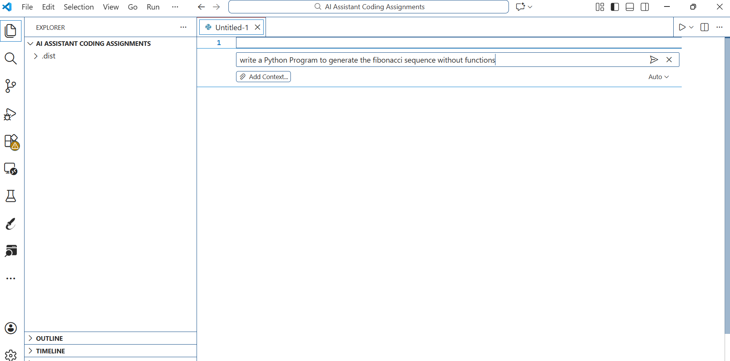
Batch 28

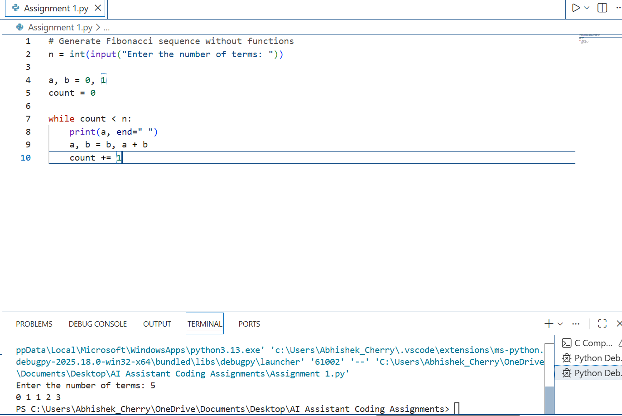

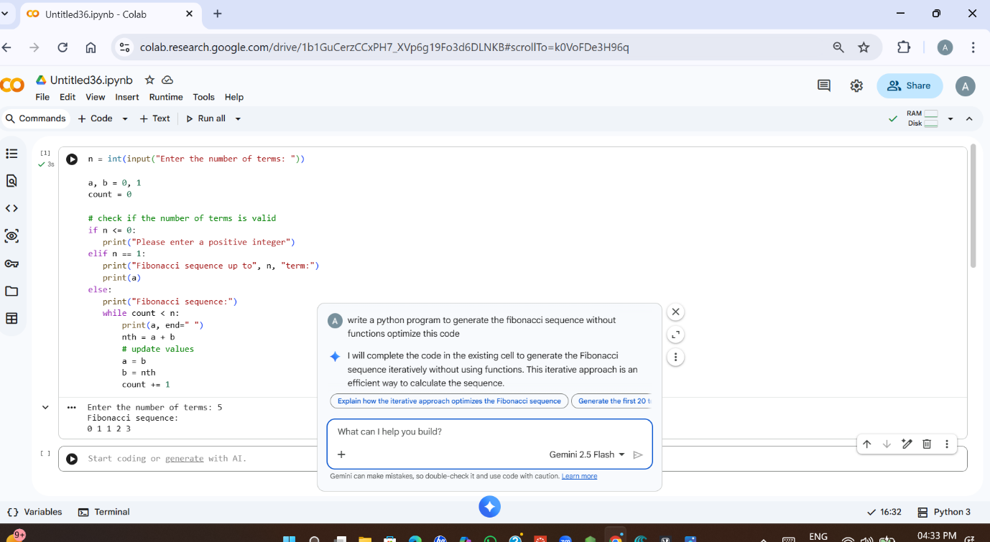
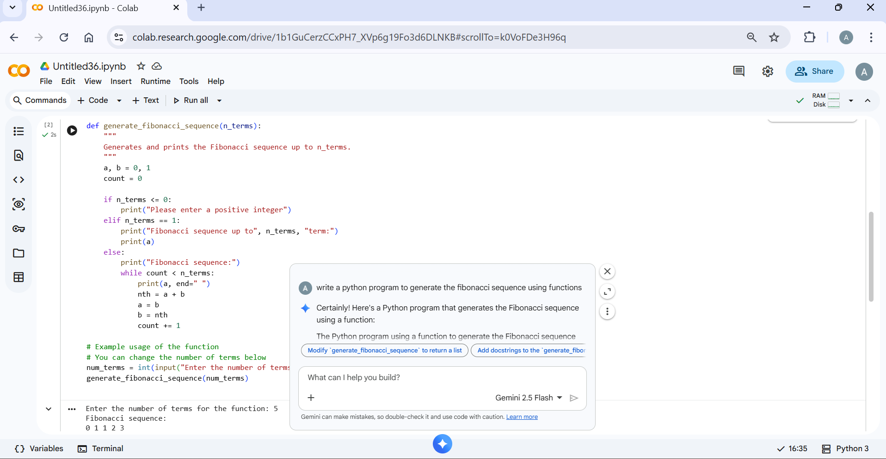
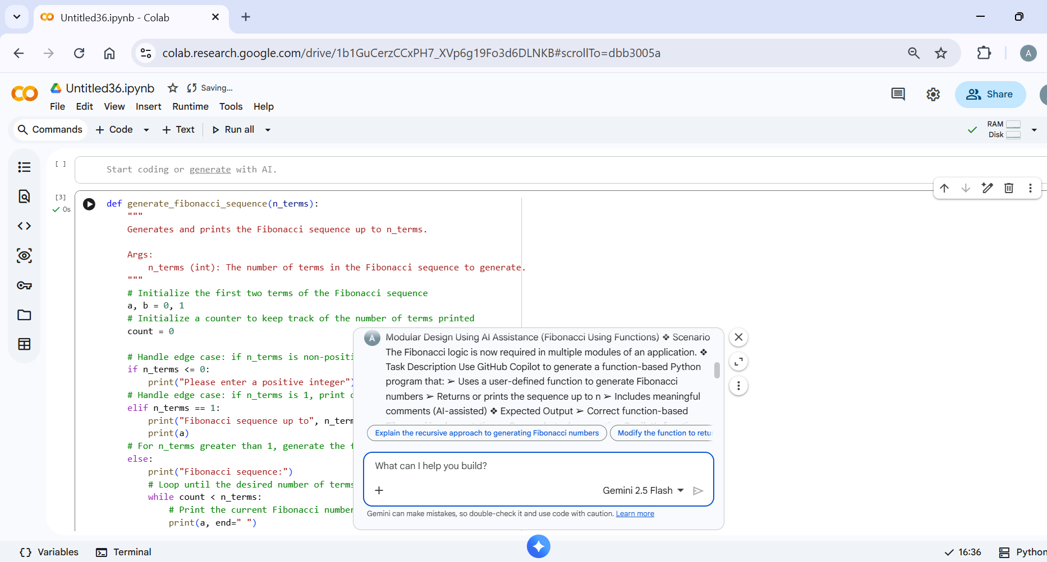
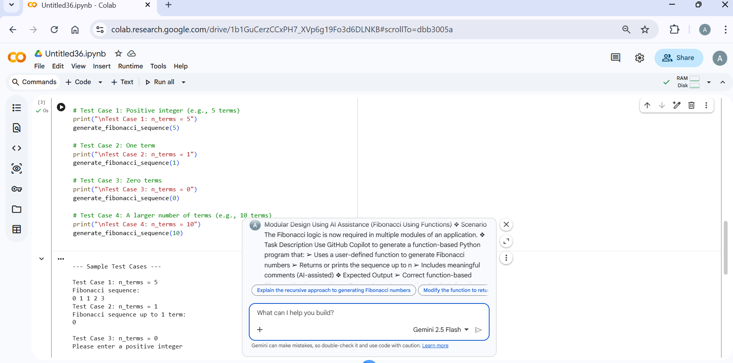

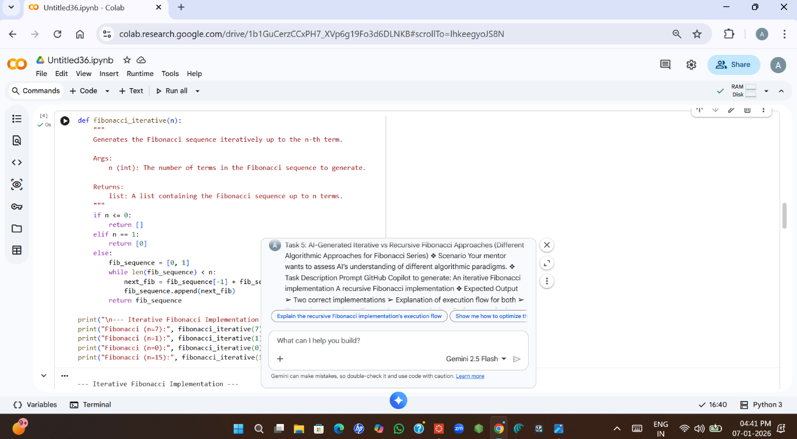
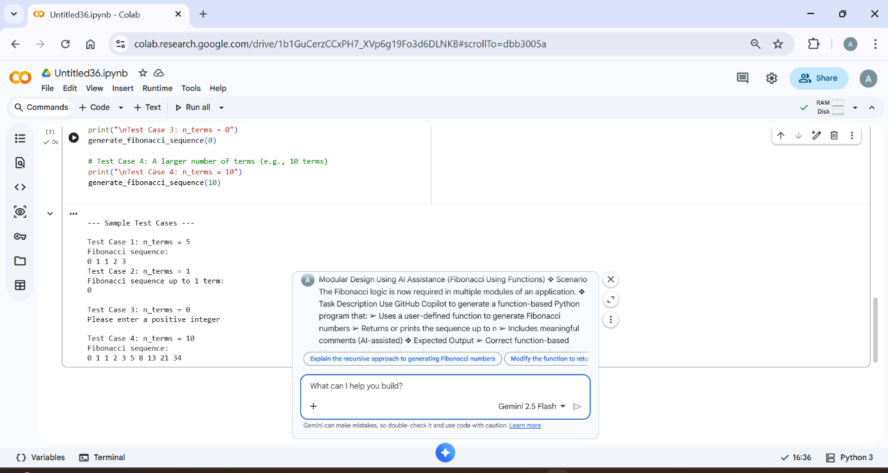

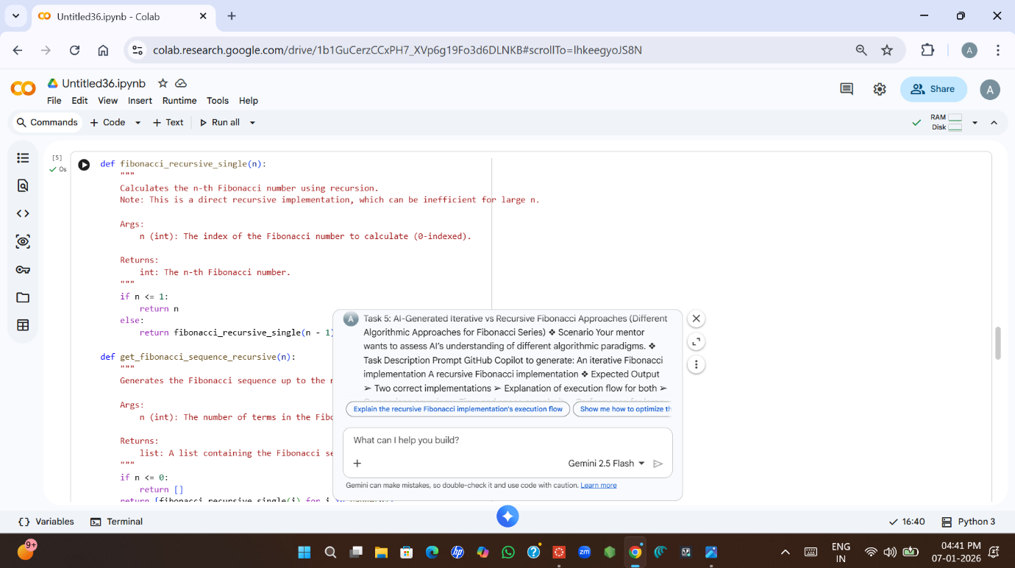
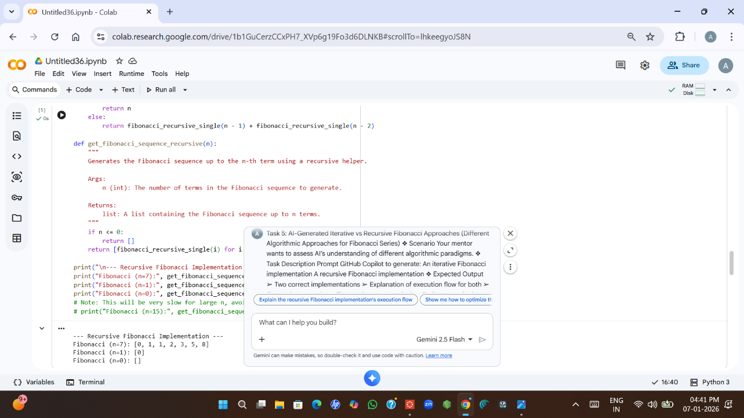
Generate and optimize Fibonacci sequence programs in Python. First, create a non-modular program that takes 'n' as input and prints the sequence up to 'n' terms. Then, optimize this non-modular code by removing inefficiencies and explain the optimizations. Next, create a modular, function-based program for the Fibonacci sequence, including AI-assisted comments. Finally, compare the optimized non-modular code with the modular code, highlighting differences in design, readability, reusability, and performance, and summarize the entire process.
To optimize the non-modular Fibonacci code, the following changes have been implemented:
- Redundant Variable Removal: The next_term variable has been eliminated. Instead of calculating next_term = a + b and then updating a and b, we directly update a and b using Python's simultaneous assignment feature: a, b = b, a + b. This reduces memory usage and simplifies the code.
- Streamlined Printing Logic: The printing of the Fibonacci sequence has been consolidated. Instead of printing the first two terms separately and then looping for the rest, the code now initializes a = 0 and b = 1. It prints the first term (a), and then iterates from the second term (b) onwards within a single loop, ensuring a consistent printing format (each term preceded by a space after the first).
- Consolidated Output: The message "Fibonacci sequence:" is now printed only once for valid inputs, maintaining clarity without repetition.

